Analytics

This is the dashboard introduction. Here are the statistics and an explanation of the analytics.

Custom Views

The number of views that have been created amongst the active user base.

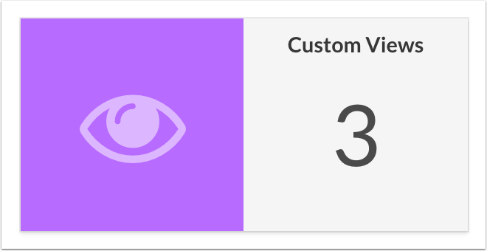

Active Users

The number of users who have used their Emory login to access the website.

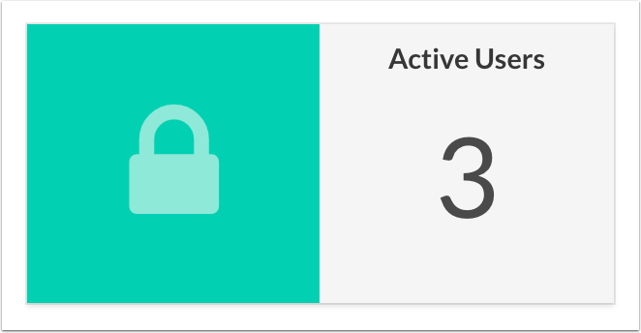

Broken Link Checker

The Broken Link Checker in the Dashboard crawls every page and child page within the Online Investigator's Guide and detects the HTTP response for the links within that page. This report runs on demand and will take a few minutes to run. You must remain on the Dashboard page for the report to complete successfully.

The report produces the following information:

1. Page Title

Administrative title of the page with the broken link

1. Link Text

Text entered within the editor that is resolving to a broken link

1. Bad URL

The URL that is resolving as a broken link

1. Error Codes

The code that the crawler sends back

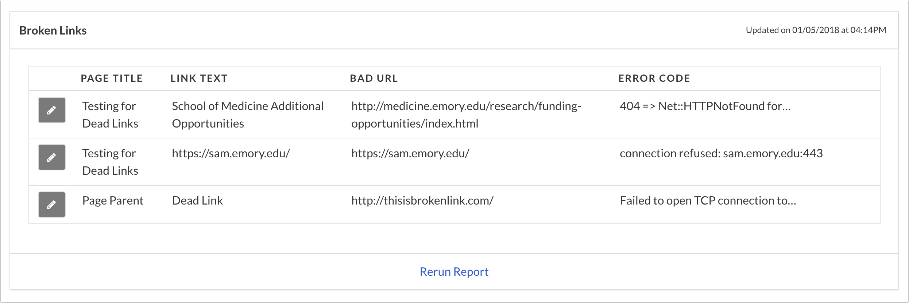

Last Time Updated

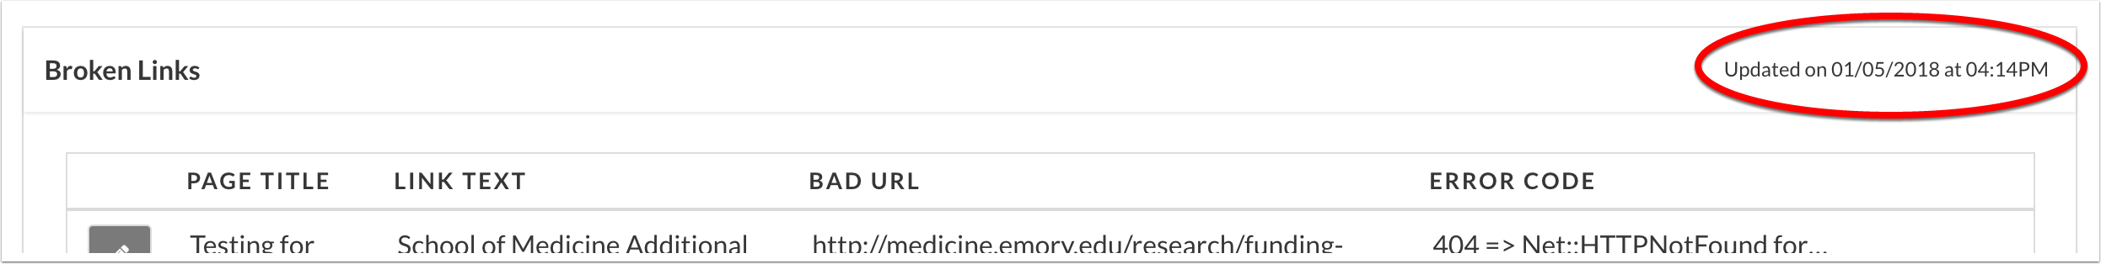

Edit Page

Click the Pencil next to the Page Title to open a new browser window and edit the offending page. Note: you will need to rerun the Broken Link Checker for the report to update.

Refreshing Report

To refresh the report, select Rerun Report from at the bottom of the report table. It will take a few minutes to run and you must remain on the Dashboard page for the report to complete successfully.

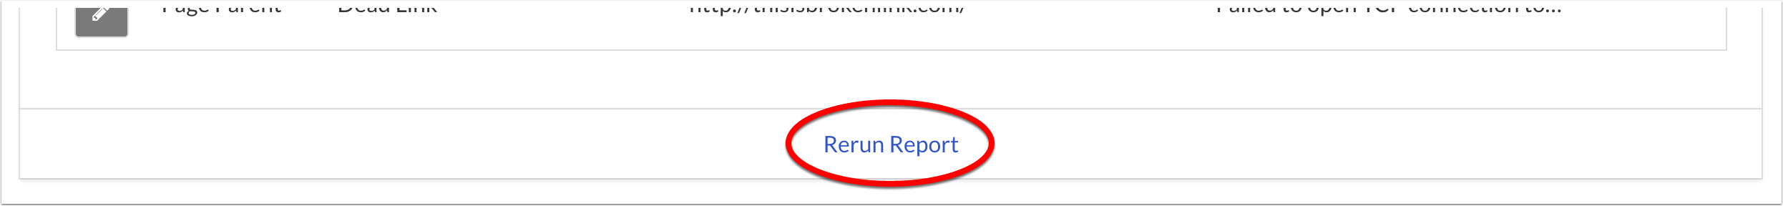

Error Codes

1. **404 => Net::HTTPNotFound for *<bad URL>* -- unhandled response**

The HTTP 404 Not Found Error means that the webpage you were trying to reach could not be found on the server. It is a Client-side Error which means that either the page has been removed or moved and the URL was not changed accordingly, or that you typed in the URL incorrectly.

1. **connection refused: *<bad URL>*:443**

This error code results in attempting to access a secured website on port 443. You specifically need to use "https://" when accessing these sites.

1. **Failed to open TCP connection to *<bad URL>***

This URL doesn't exist and cannot be reached.

Survey Templates

A Survey Template is the questionnaire that the user will fill out to create their custom view. The system allows multiple survey templates to be created, however the survey template marked as **default** will be the only survey that is displayed to the user.

The action enabled on a survey template are:

1. Set a default survey template
2. View a survey template
3. Edit survey template
4. Delete survey template

A default template is necessary and you can not delete a survey template if it is set as default. You will not be able to delete a survey template if there is only one.

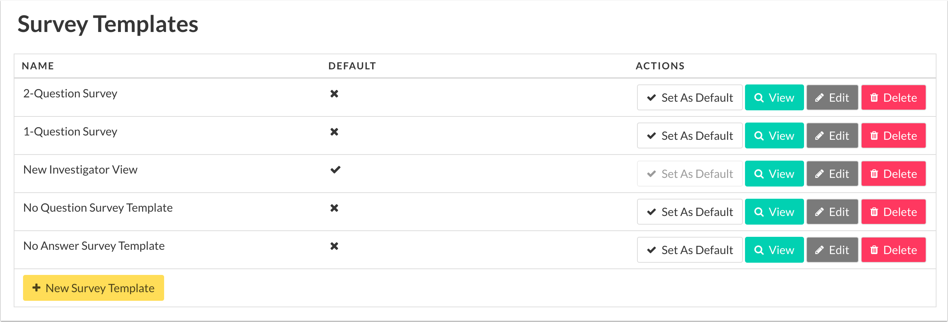

Adding New Survey Template

For details on Survey Template form, see Adding or Editting a Survey Template



Setting a Default Template

To change the default template, select Set As Default button.



View Survey Template

Viewing a Survey Template will show you:

1. Questions
2. Answers
3. Labels mapped to answers

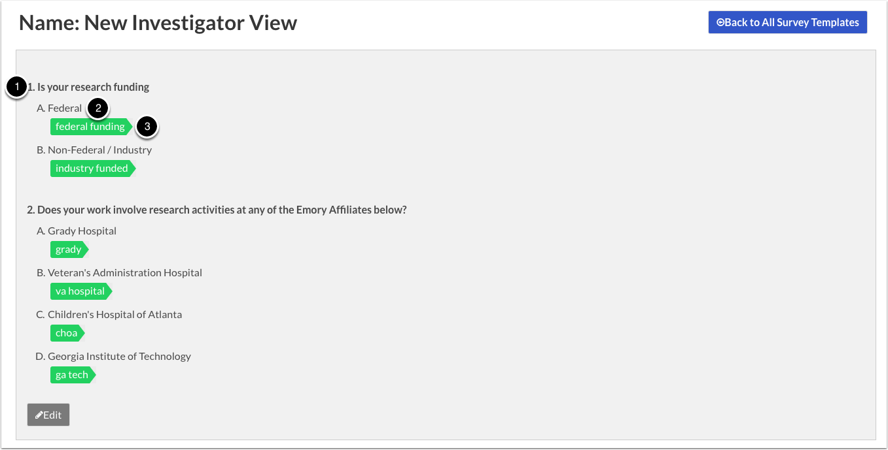

Adding or Editing a Survey Template

When adding or editing an existing survey template, you can configure the following options:

1. Survey Name

The User will see this name when they are filling out their survey.

1. Default Template

Toggle Default template

1. Add New Question

Each Survey Template requires as least one question

1. Question Text
2. Question Type

Multiple = Checkbox

One = Radio Button

1. Remove Question
2. Add Answer to Question

Each Question requires as least one answer

1. Question Text
2. Select Labels

Content is mapped to specific labels. Selecting labels on this page will determine which content shows up when the user answers the question with that specific answer.

1. Remove Answer
2. Save Survey Template

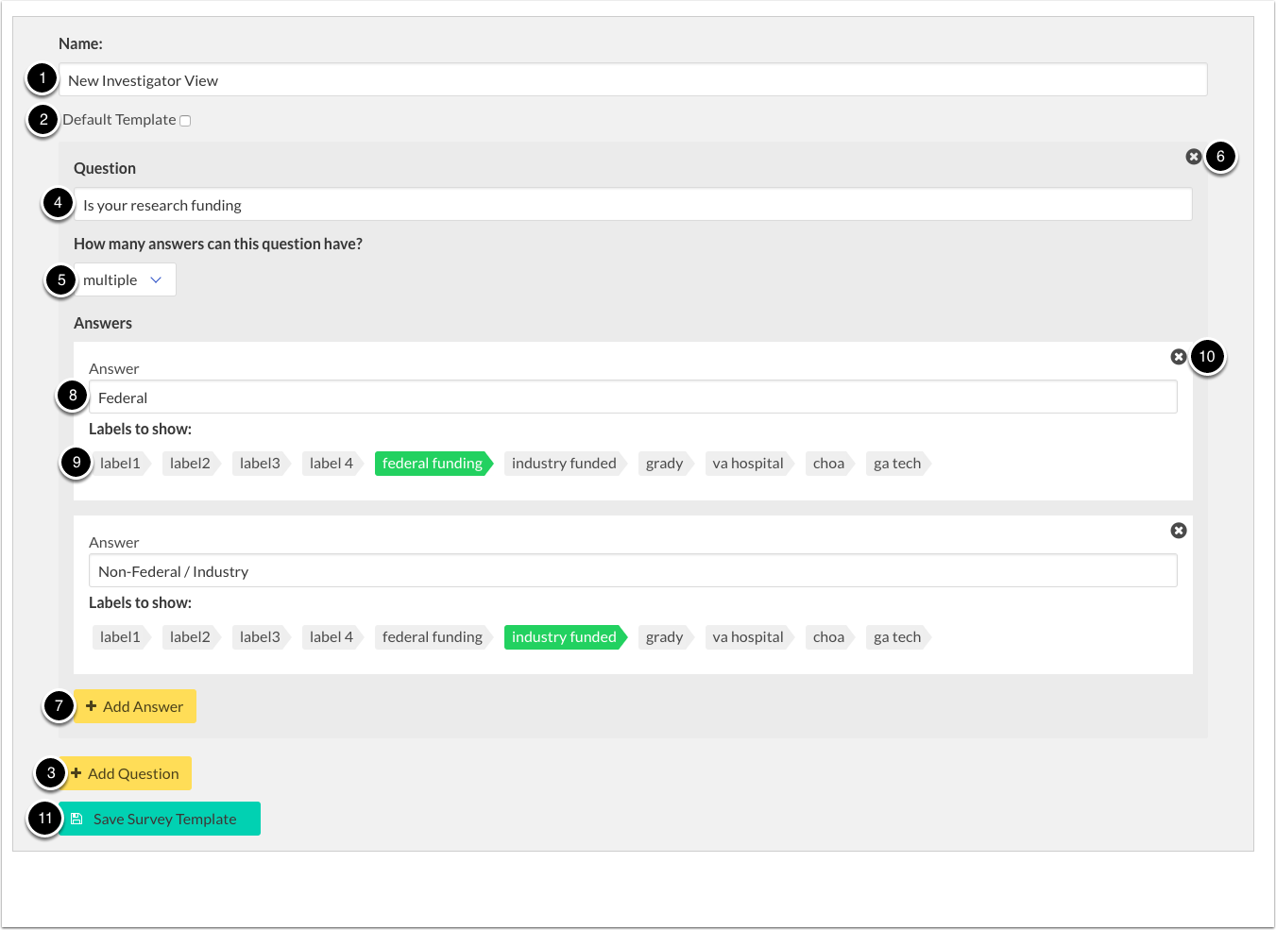

Labels

Labels are used to group content that can be mapped to a survey template answer. If the survey template answer is mapped to a label, only the content with that label will show up if the user has selected that specific answer.

The following actions can be done on labels:

1. Edit Existing Label

Editing an existing label will not change any content or answers you have linked

1. Delete Label
2. Add New Label

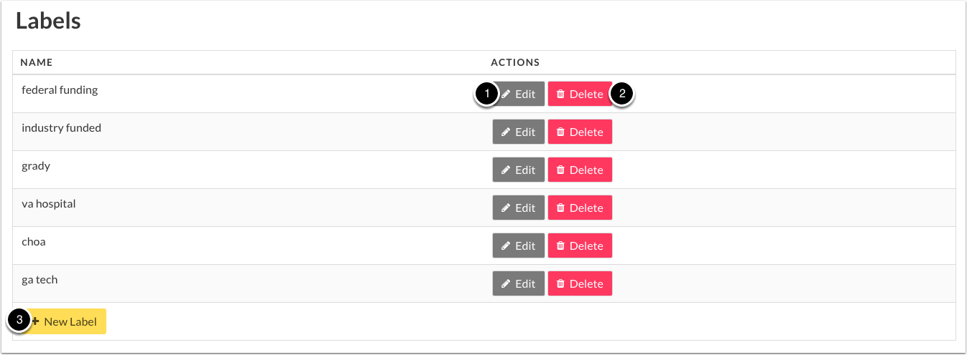

Pages

Pages are the primary content of the website. Pages can be nested within other pages (up to 4 levels deep), allowing granularity when mapping to labels and specific survey answer questions.

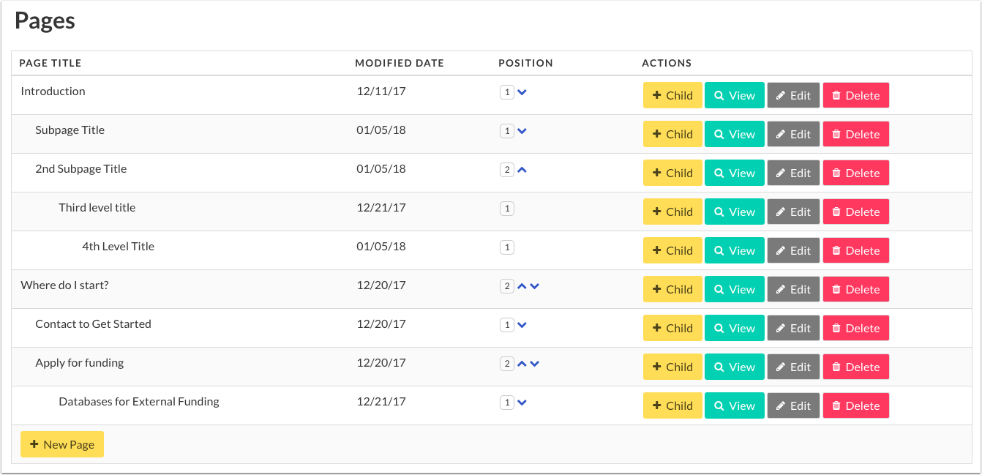

Adding New Page

When Adding New page, you can configure the following options:

1. Page Title

This is what will show up on the table of contents and the left navigation menu.

1. Page Header

This is the large text at the beginning of the section.

1. Parent Page

If desired, select the parent page from the drop down list.

1. Page Body

Content that will show up on the page. For more detailed instructions, visit Formatting Page Body.

1. Label

Select labels that will be mapped to answer questions and other content. Selected labels will turn green.

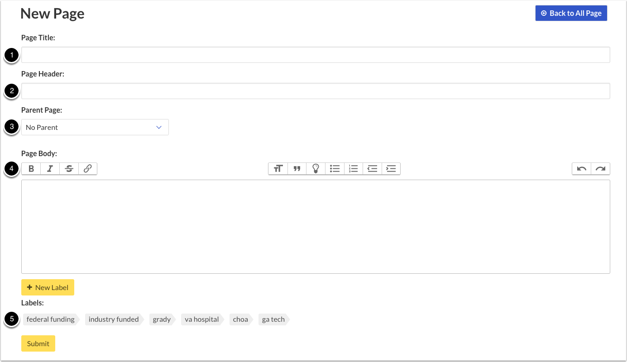

Parent Page Structure

1. Parent Page Title
2. Parent Page Title
3. Parent Page Header
4. Child Pages
5. Child Page Header
6. Child Page Body

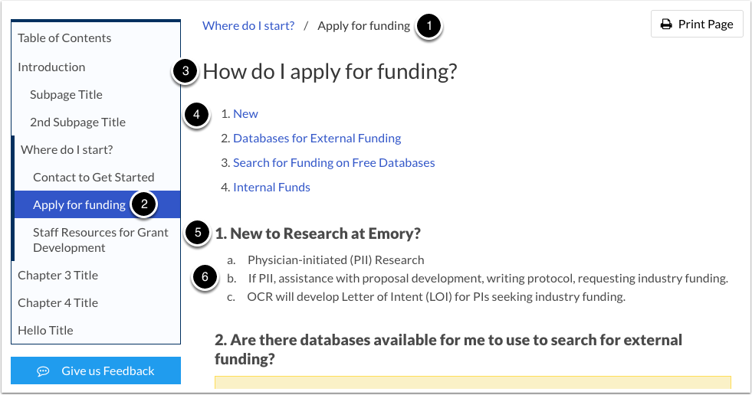

Formatting Page Body

The toolbar at the top of the Page Body editor allows you to have full customization over your content. From left to right:

1. Bold Text
2. Italics Text
3. Strikethrough Text
4. Hyperlink Text
5. Enlarge Text
6. Blockquote
7. Lightbulb Text (see example below)
8. Bulleted List
9. Numbered List
10. Decrease Indent
11. Increase Indent
12. Undo
13. Redo

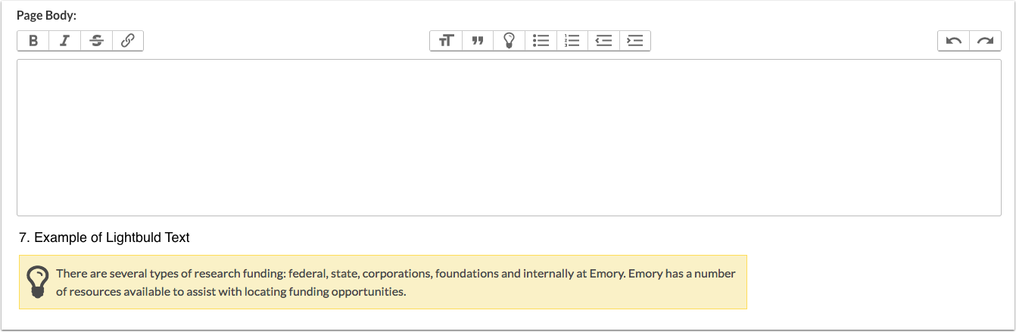

Mapping Pages to Labels

Mapping Pages to Labels indicates which pages will show up for a specific answer.

1. Select the flag at the bottom of the page
2. It will turn green to indicate that it is active

To add a new label from this page:

1. Select New Label
2. Enter Text and Select Save
3. The New Label will show up in the labels list

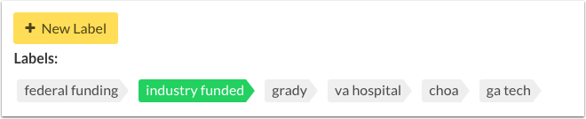

Reordering Pages

Select the appropriate arrow to move the page up or down in the outline

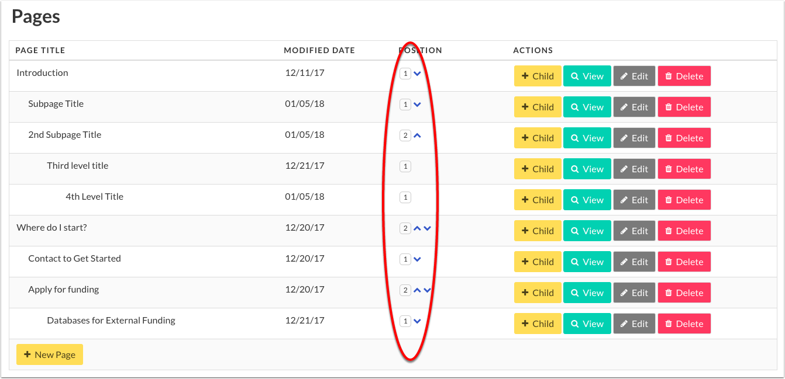

Supporting Units

Supporting Units will appear in the upper right corner of the website on desktop and the footer on mobile devices.

Each supporting unit needs the following information to be valid:

1. Unit

This is what will show up in the list

1. Title

Used for accessibility purposes

1. URL

URL that the link will direct to

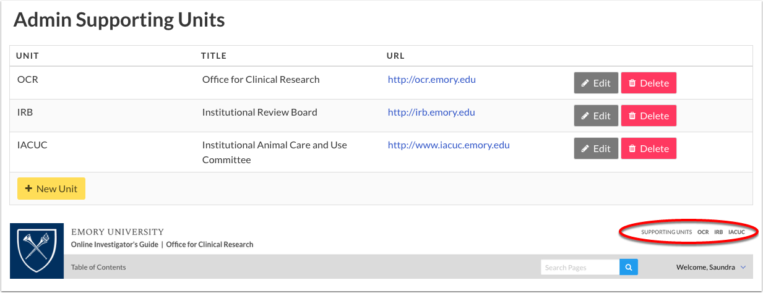

User Management

User Management has a comprehensive list of all users that have logged into the website and if they have administrative privileges. This list that can be filtered by NETID or NAME. From this table, you can revoke or grant admin privileges accordingly by selecting the appropriate button next to the user's name.

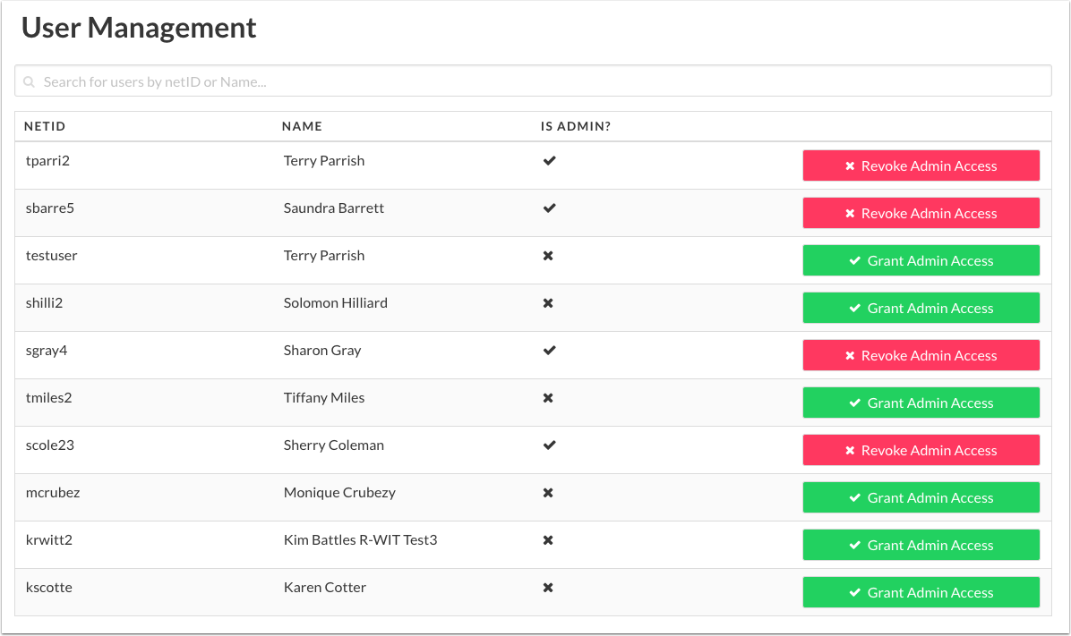

Site Information

Site Information give you access to modify basic site information as well as place the website into maintenance mode.

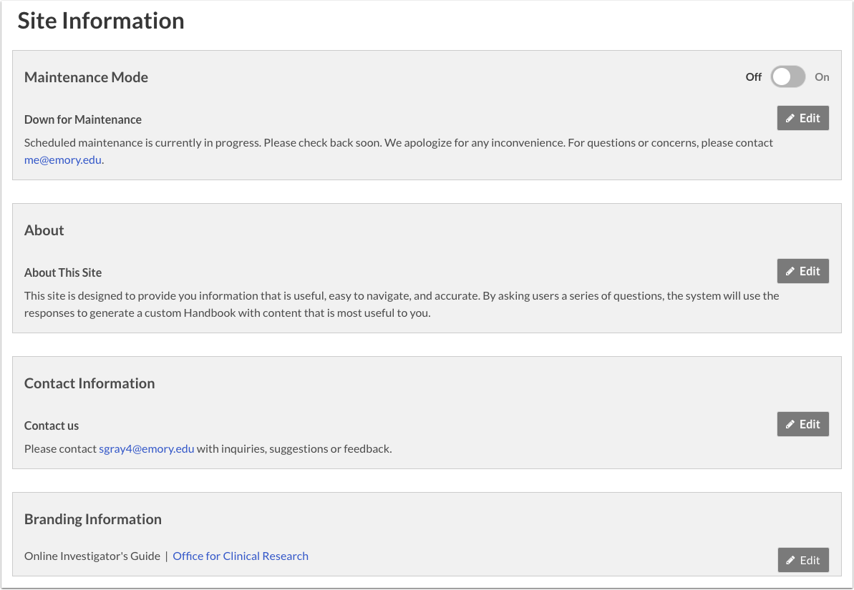

Maintenance Mode

Maintenance Mode is to be used when the site needs to be inaccessible to the user.

1. Use the Toggle Switch to turn maintenance mode off or on
2. To edit the maintenance message that the End User will see, select Edit.

We recommend customizing your message to the end user with an indication of when the site will be out of maintenance mode

1. When maintenance mode is on, there will be an indicator at the top of the screen within the administrative portal

You can turn off maintenance mode from this indicator by clicking "Turn off maintenance mode"

1. When maintenance mode is on, every page for the end user will deliver your maintenance message

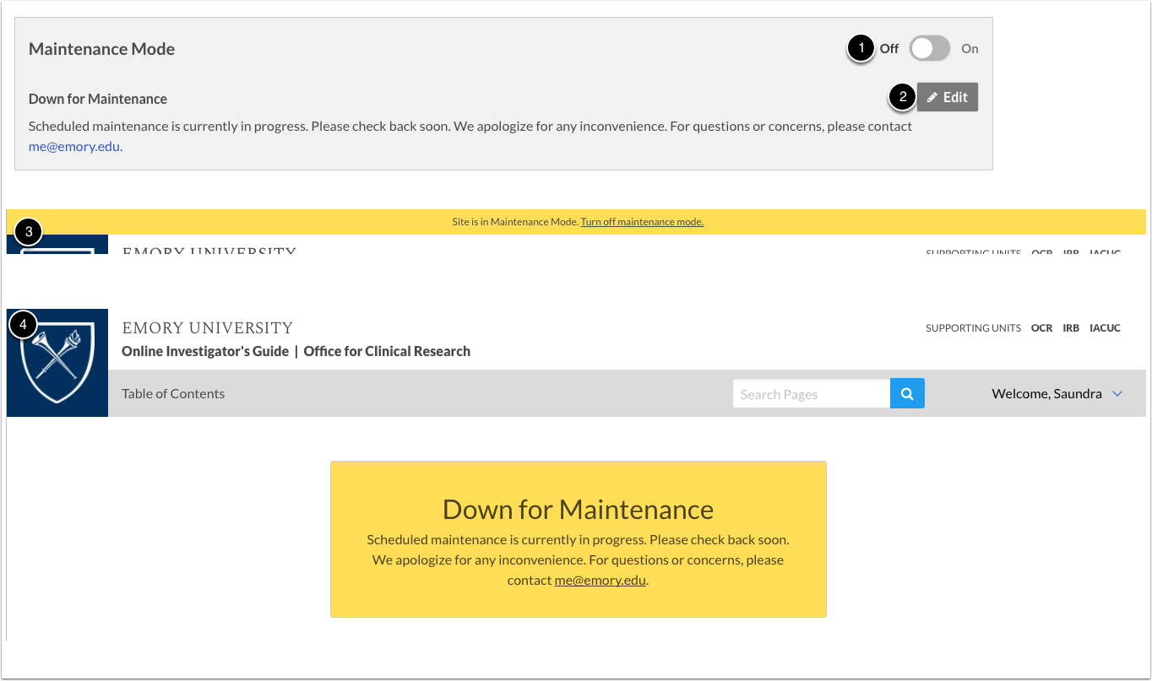

About

This introduction text can be found within the page footer at the bottom of the page.

To edit about:

1. Select Edit
2. Edit Header
3. Edit Body

Links are allowed

1. Save

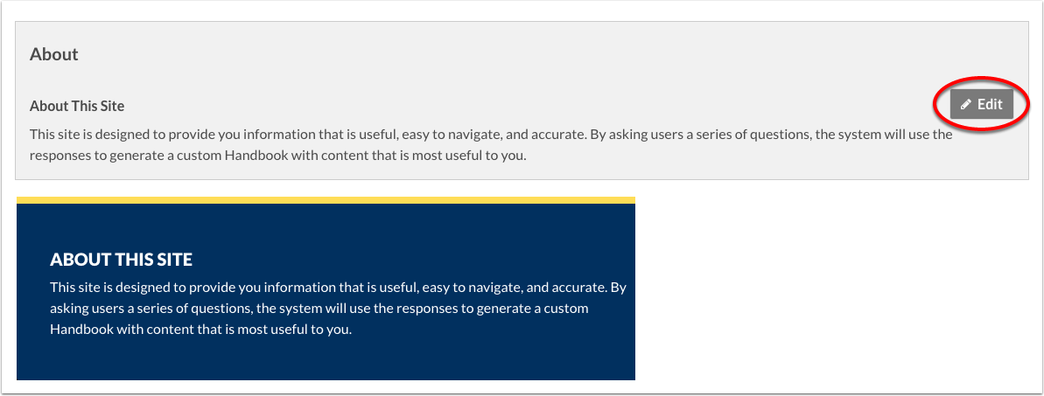

Contact Information

Contact Information can be found within the page footer at the bottom of the page.

To edit contact information:

1. Select Edit
2. Edit Header
3. Edit Body

Links are allowed

1. Save

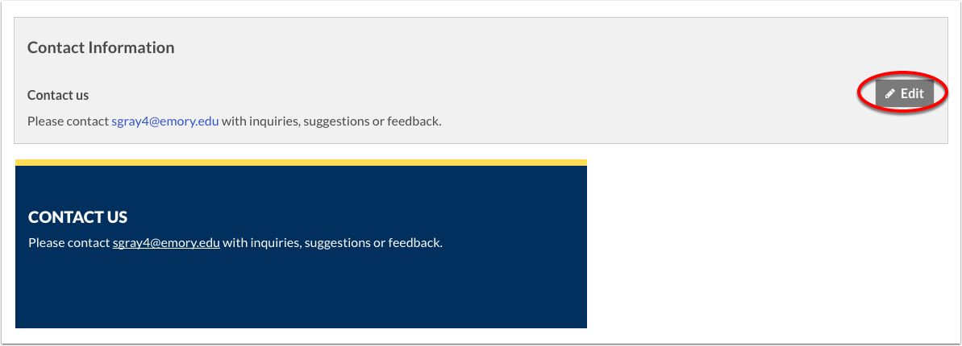

Branding Information

Branding information is found within the page header at the top of page.

To edit branding information:

1. Select Edit
2. Edit Text

Links are allowed

1. Save

